**1. Функции и процедуры для выполнения CRUD-операций (общая база данных).**

1.1 create or replace procedure pr_add_ сustomers(new_id integer,name varchar(50))

language plpgsql as $$

begin

insert into сustomers (customer_id,first_name) values (new_id,name);

end;

$$;

call pr_add_category(9,'Vlad')

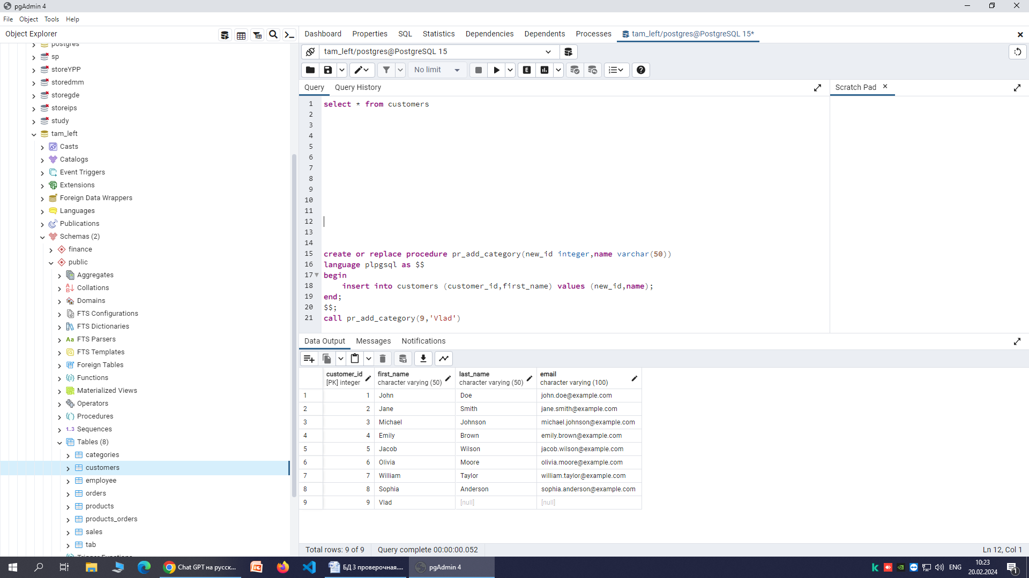

create or replace procedure pr_update_сustomers(cur_id integer, name_new varchar(50))

language plpgsql as $$

begin

update сustomers set first_name = name_new where customer_id = cur_id;

end;

$$;

call pr_update_сustomers(9,'Karina')

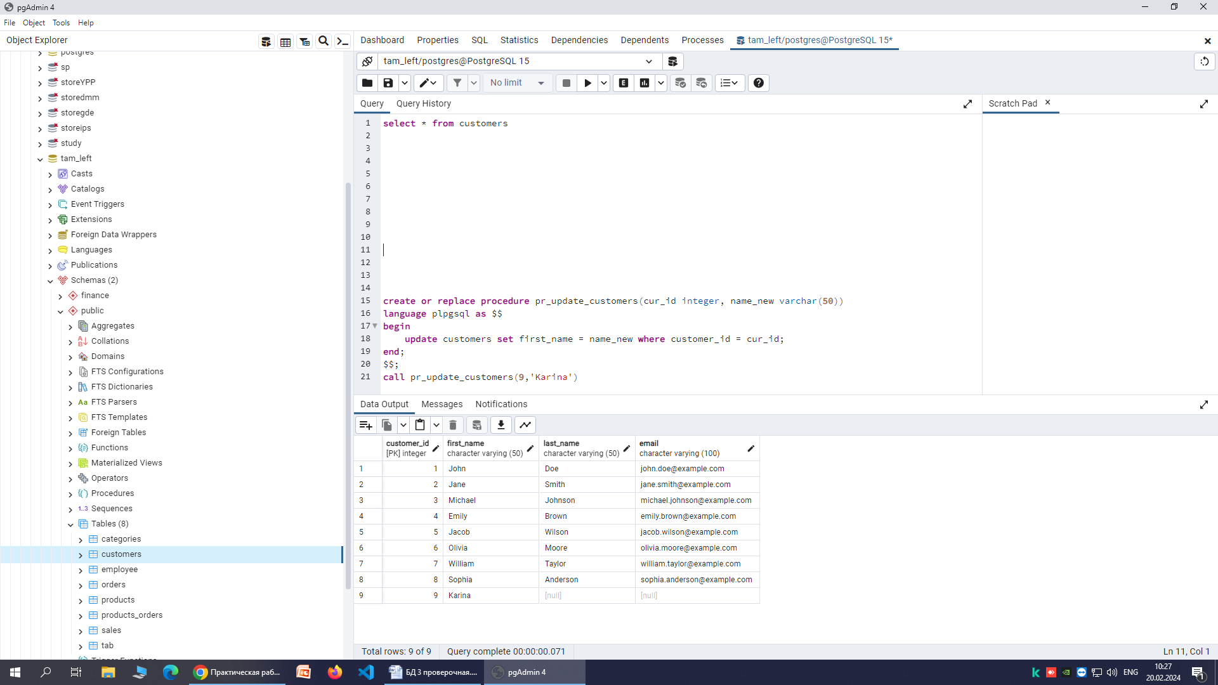

create or replace procedure pr_delete_сustomers(cur_id integer)

language plpgsql as $$

begin

delete from сustomers where customer_id = cur_id;

end;

$$;

call pr_delete_сustomers(9)

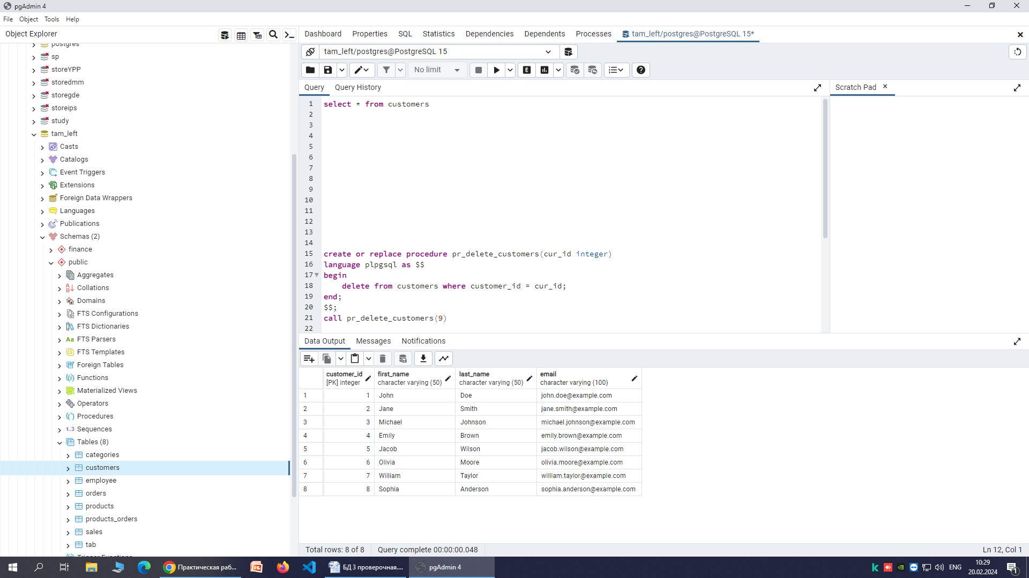

1.2 create or replace function f_add_products(id integer,name varchar(50))

returns integer as $$

begin

insert into products (product_id,product_name) values (id, name);

return id;

end;

$$ language plpgsql;

select * from f_add_products(5,'Mouse')

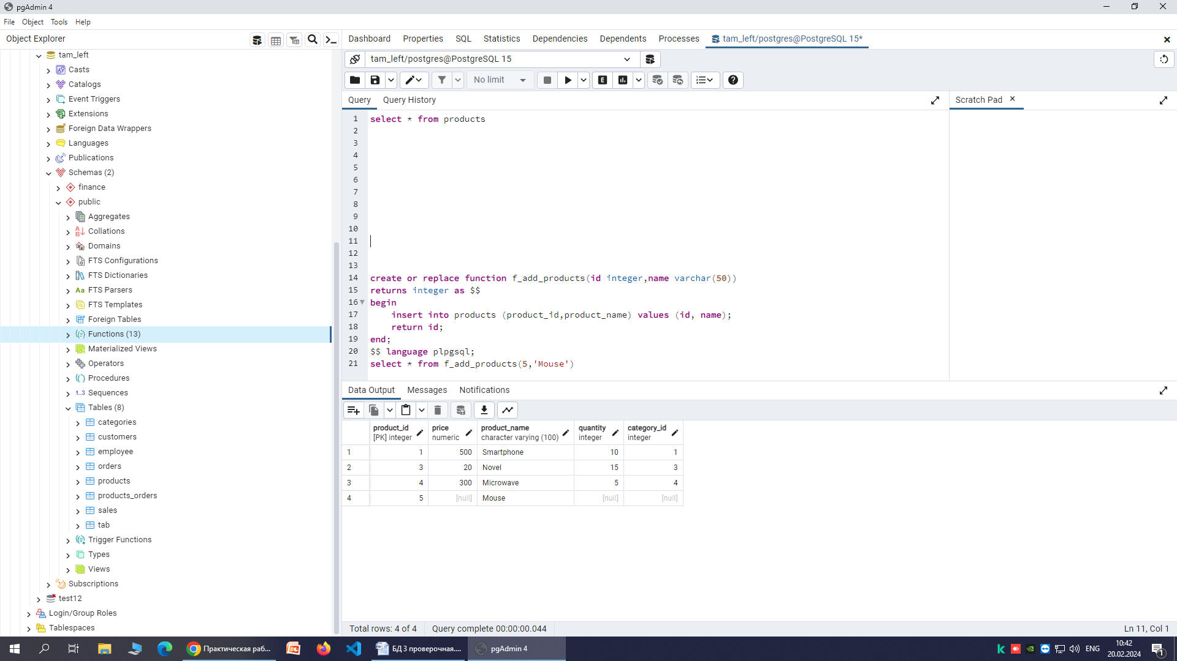

create or replace function f_update_products(cur_id integer, name_new varchar(50))

returns integer as $$

begin

update products set product_name = name_new where product_id = cur_id;

return product_id;

end;

$$ language plpgsql;

select * from f_update_products(5,'Keyboard')

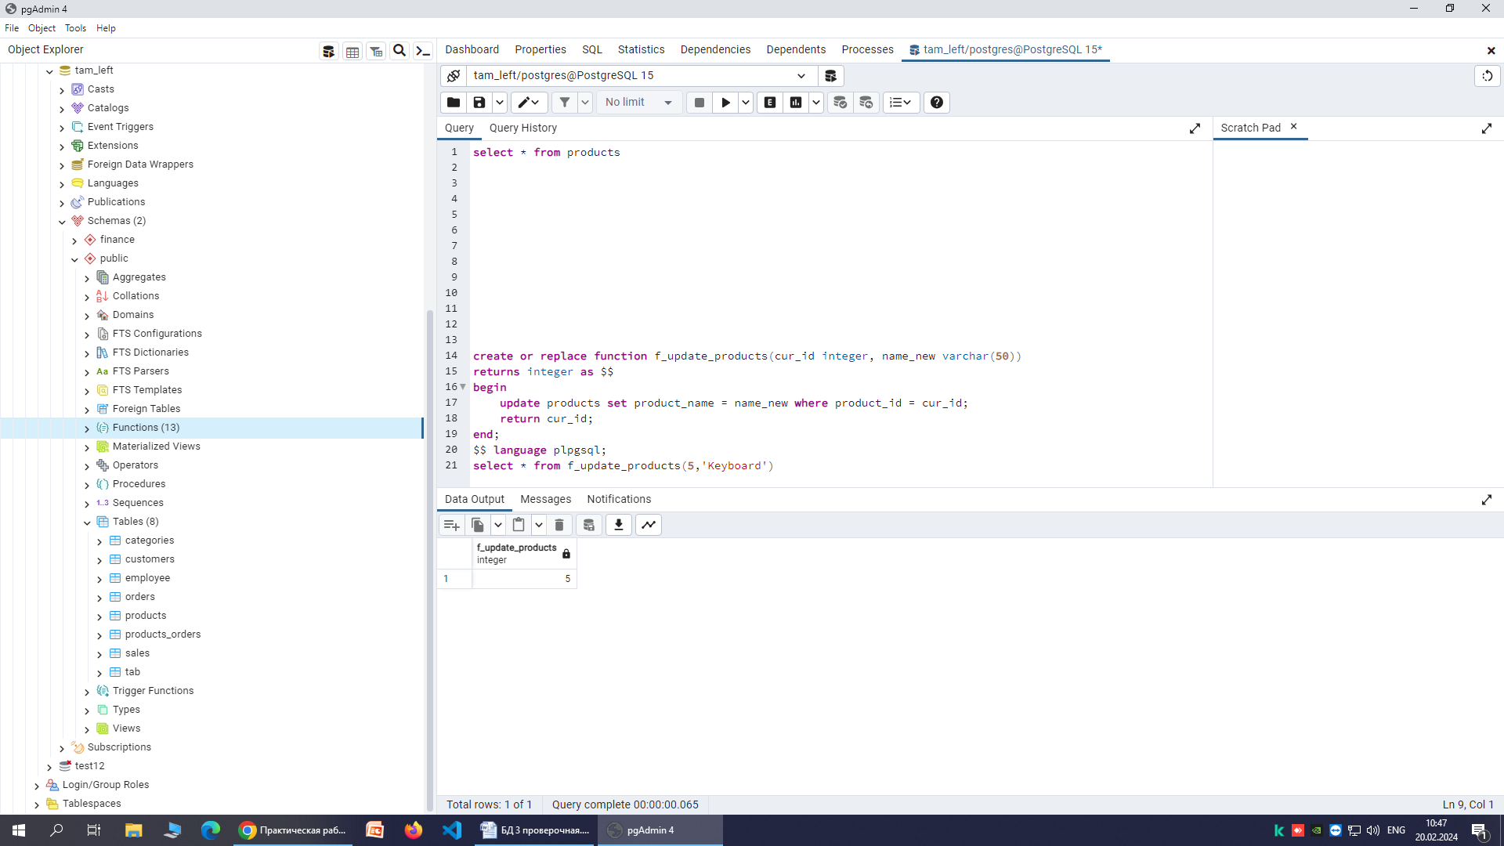

create or replace function f_delete_products(cur_id integer)

returns integer as $$

begin

delete from products where product_id = cur_id;

return cur_id;

end;

$$ language plpgsql;

select from f_delete_products(5)

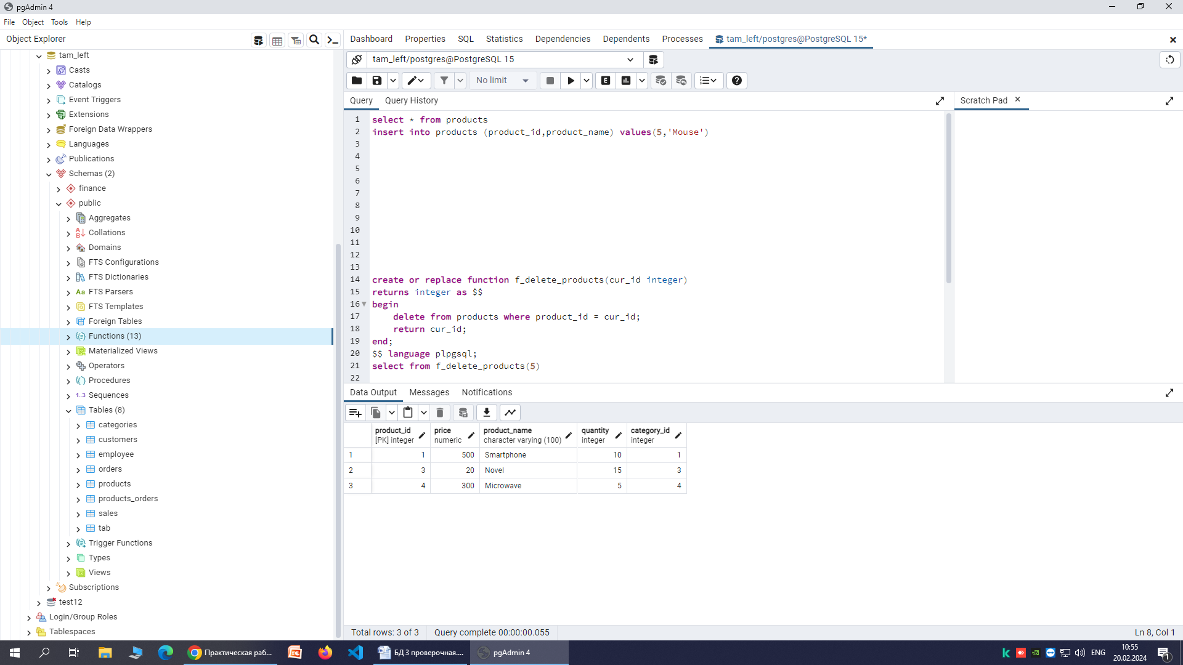

create or replace function f_select_category(cur_id integer)

returns products

as $$

select * from products where id = cur_id;

$$ language sql;

select * from f_select_category(3);

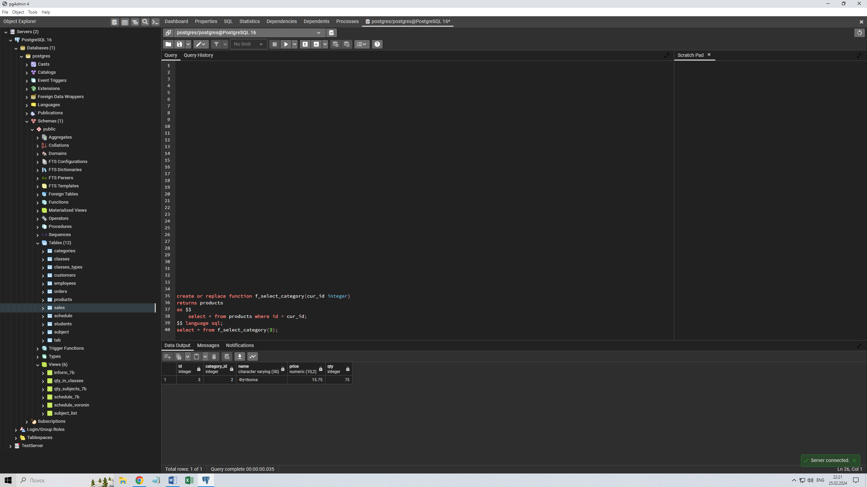

**2. Одиночные курсоры**

2.1 create or replace function get_cursor (curs1 refcursor)

returns refcursor as $$

begin

open $1 for select * from categories;

return $1;

end;

$$ language plpgsql;

select * from get_cursor ('curs01');

fetch all in curs01

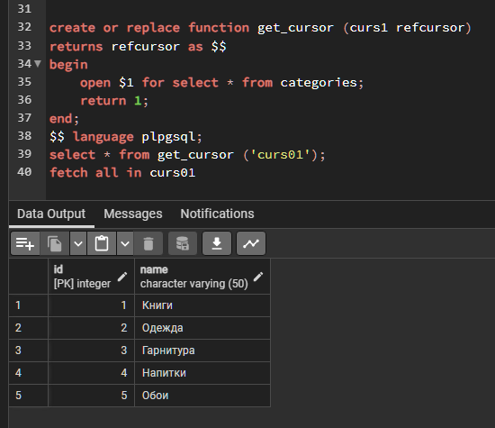

2.2 create or replace function difcursor()

returns varchar(50) as $$

declare

curs1 cursor for select name from products where category_id=3;

nm varchar(50);

begin

open curs1;

RAISE NOTICE 'Товары с категорией 3:';

loop

fetch curs1 into nm;

EXIT WHEN NOT FOUND;

RAISE NOTICE '%', nm;

return next nm;

end loop;

close curs1;

end;

$$ language plpgsql;

select * from difcursor()

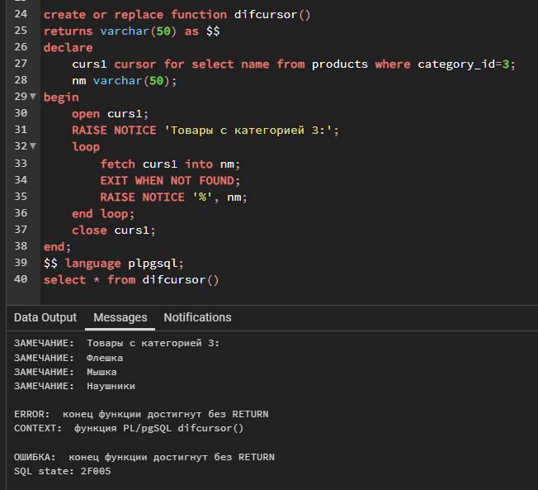

2.3 create or replace function get_cursor3()

returns numeric(15,2) as $$

declare

curs1 cursor for select dis_amount from orders where datee='2023-10-01';

pay numeric(15,2):=0;

summ numeric(15,2):=0;

begin

open curs1;

loop

fetch curs1 into pay;

EXIT WHEN NOT FOUND;

summ:=summ+pay;

end loop;

return summ;

close curs1;

end;

$$ language plpgsql;

select * from get_cursor3();

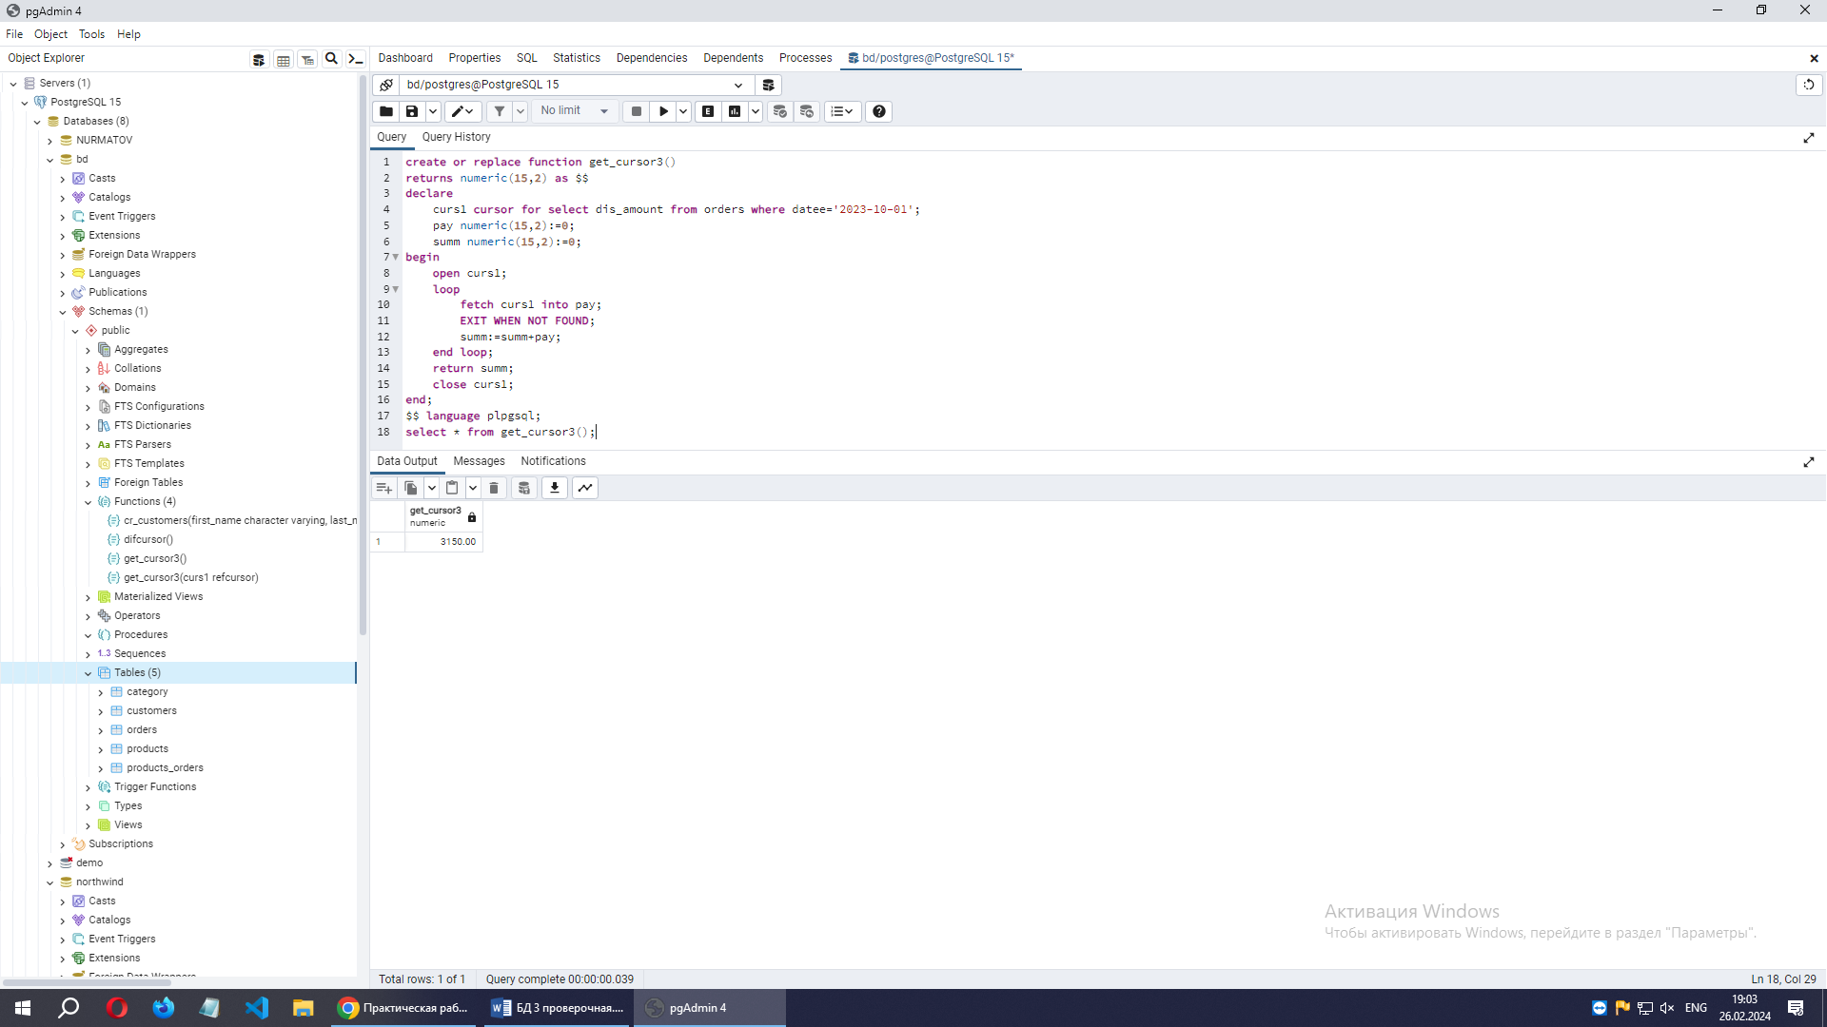

2.4

create or replace procedure get_cursor_p(out refcursor, out refcursor)

as $$

begin

open $1 for SELECT * FROM clients WHERE phone LIKE '_951%';

open $2 for SELECT * FROM clients WHERE phone LIKE '_982%';

end;

$$ language plpgsql;

do $$

declare

a refcursor:='a';

b refcursor:='b';

tmpa record;

tmpb record;

begin

call get_cursor_p(a,b);

fetch from a into tmpa;

raise notice 'Номера на 951:';

while (found) loop

raise notice '%', tmpa;

fetch from a into tmpa;

end loop;

fetch from b into tmpb;

raise notice 'Номера на 982:';

while (found) loop

raise notice '%', tmpb;

fetch from b into tmpb;

end loop;

end;

$$

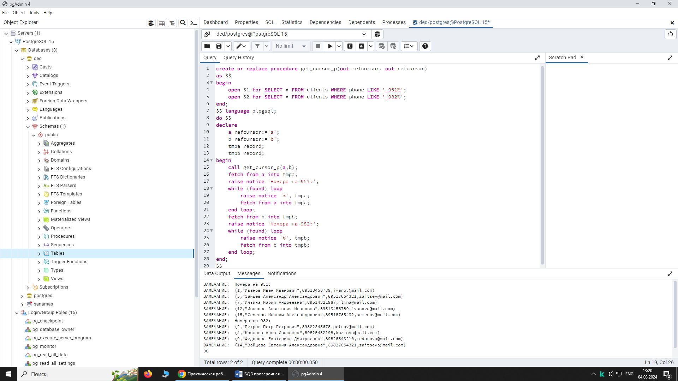

2.5 create or replace procedure get_cursor_2_5()

as $$

declare

curs1 cursor for SELECT * FROM clients WHERE phone LIKE '_91%' for update;

tmpa record;

begin

raise notice 'Номера на 917:';

open curs1;

loop

fetch from curs1 into tmpa;

EXIT WHEN NOT FOUND;

if (tmpa.phone like '_917%') then

UPDATE clients SET phone = CONCAT(SUBSTRING(phone, 1,1),'982', SUBSTRING(phone,5)) WHERE CURRENT OF curs1;

raise notice '%', tmpa.id;

else delete from clients where CURRENT OF curs1;

end if;

end loop;

close curs1;

end;

$$ language plpgsql

call get_cursor_2_5()

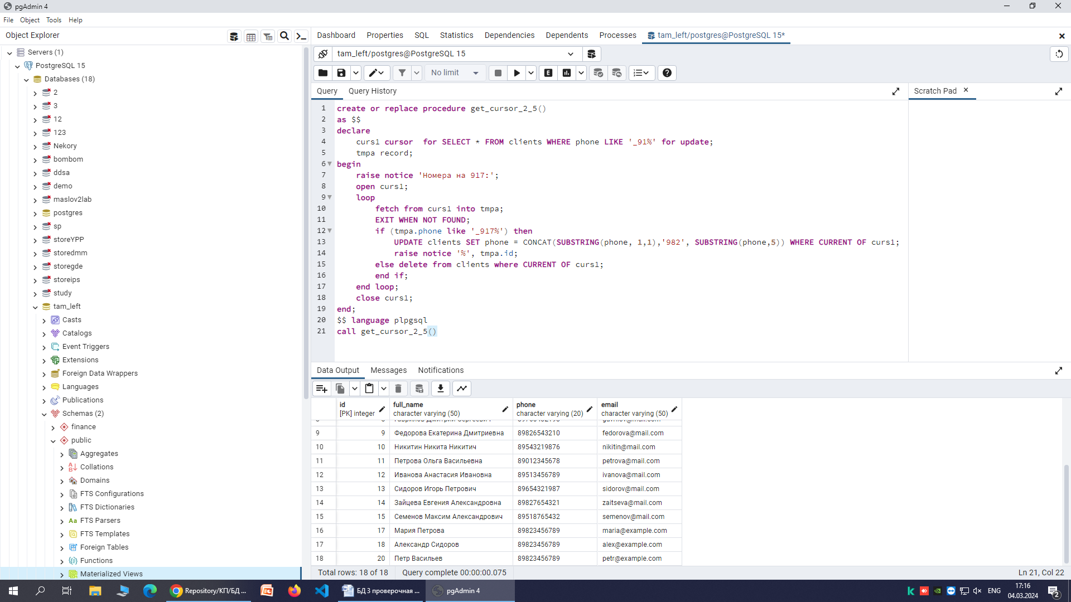

2.6

CREATE TABLE сustomers (

customer_ID INT PRIMARY KEY,

first_Name VARCHAR(50),

last_Name VARCHAR(50),

email VARCHAR(100)

)

INSERT INTO сustomers VALUES

(1, 'John', 'Doe', 'john.doe@example.com'),

(2, 'Jane', 'Smith', 'jane.smith@example.com'),

(3, 'Michael', 'Johnson', 'michael.johnson@example.com'),

(4, 'Emily', 'Brown', 'emily.brown@example.com'),

(5, 'Jacob', 'Wilson', 'jacob.wilson@example.com'),

(6, 'Olivia', 'Moore', 'olivia.moore@example.com'),

(7, 'William', 'Taylor', 'william.taylor@example.com'),

(8, 'Sophia', 'Anderson', 'sophia.anderson@example.com');

CREATE TABLE clients (

id INT PRIMARY KEY,

full_name VARCHAR(50),

phone VARCHAR(20),

email VARCHAR(50)

);

delete from clients

INSERT INTO clients VALUES

(1, 'Иванов Иван Иванович', '89513456789', 'ivanov@mail.com'),

(2, 'Петров Петр Петрович', '89822345678', 'petrov@mail.com'),

(3, 'Сидорова Ольга Петровна', '89654321987', 'sidorova@mail.com'),

(4, 'Козлова Анна Ивановна', '89825432198', 'kozlova@mail.com'),

(5, 'Зайцев Александр Александрович', '89517654321', 'zaitsev@mail.com'),

(6, 'Семенова Елена Владимировна', '89098765432', 'semenova@mail.com'),

(7, 'Ильина Мария Андреевна', '89514321987', 'ilina@mail.com'),

(8, 'Гаврилов Дмитрий Сергеевич', '89765432198', 'gavrilov@mail.com'),

(9, 'Федорова Екатерина Дмитриевна', '89826543210', 'fedorova@mail.com'),

(10, 'Никитин Никита Никитич', '89543219876', 'nikitin@mail.com'),

(11, 'Петрова Ольга Васильевна', '89012345678', 'petrova@mail.com'),

(12, 'Иванова Анастасия Ивановна', '89513456789', 'ivanova@mail.com'),

(13, 'Сидоров Игорь Петрович', '89654321987', 'sidorov@mail.com'),

(14, 'Зайцева Евгения Александровна', '89827654321', 'zaitseva@mail.com'),

(15, 'Семенов Максим Александрович', '89518765432', 'semenov@mail.com');

INSERT INTO clients (ID, full_name, phone, email) VALUES (16, 'Иван Иванов', '89134556789', 'ivan@example.com');

INSERT INTO clients (ID, full_name, phone, email) VALUES (17, 'Мария Петрова', '89173456789', 'maria@example.com');

INSERT INTO clients (ID, full_name, phone, email) VALUES (18, 'Александр Сидоров', '89173456789', 'alex@example.com');

INSERT INTO clients (ID, full_name, phone, email) VALUES (19, 'Екатерина Николаева', '89151345789', 'ekaterina@example.com');

INSERT INTO clients (ID, full_name, phone, email) VALUES (20, 'Петр Васильев', '89173456789', 'petr@example.com');